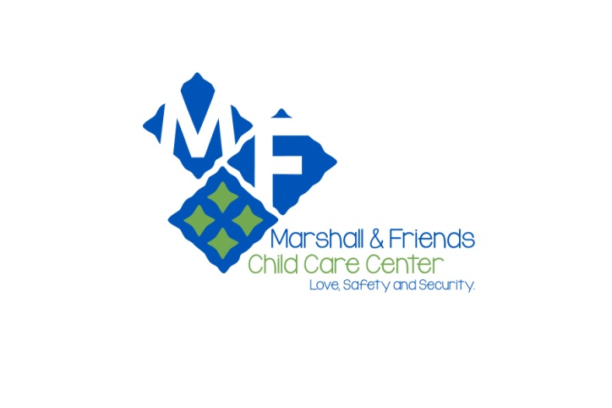

“GETTING TO KNOW YOU”

We are asking that parents and children involved in our programs participate in a brief survey and questionnaire that will help us create a better understanding of your child, your family and your expectations of our program. We respect and understand your right to privacy and the purpose of this survey is to ensure that your children are receiving the best care possible for each individual child. Please answer the questions honestly and know that your responses will only be reviewed by the Administration and staff directly involved with the care of your child. Please feel free to contact us to discuss any information you may not be comfortable answering on the survey. If you would prefer to discuss the survey in person an appointment can be arranged at your convenience.

The first section is general information about your family and life at home. The second section is for you to do with your child. This section will allow us to better understand your child’s likes and dislikes which will aid us in designing a program better suited to the preferences of the children within the group. The third section pertains to your child’s educational experiences, possible limitations, health and safety issues and general well-being. The information you provide here will aid us in providing the most effective environment, learning experiences and appropriate atmosphere for your child to spend their out of school time.

We thank you in advance for your cooperation and the time dedicated to completing the survey. Please return to the office upon completion.

Thank you,

Administration Department

Child’s Name _________________________________________ Date: ____________

Section 1 – Family Information and Special Situations

Please tell us about your household. (neighborhood, who lives with you, names and relationships to child)
________________________________________________________________________
________________________________________________________________________
Does your child have any parents who do not live in the home? Yes No
Does your child visit this parent? Yes No

Are there any custody issues that we need to be aware of? Yes No
If Yes, please explain:
__________________________________________________________________ __________________________________________________________________

Does your child have any siblings? Yes No
If Yes, please list names and ages:
__________________________________________________________________

Does your family have any pets? Yes No
If Yes, please list types and names:
__________________________________________________________________

Does your child respond to any nicknames? Yes No
If Yes, please list:
__________________________________________________________________

Does your child have any nicknames for family members? Yes No
If Yes, please list:
__________________________________________________________________

Is there any other information about your family’s composition that
you would like to share? Yes No
If Yes, please explain:
__________________________________________________________________

Does your family have a religious faith? Yes No
If Yes, please state religion:
__________________________________________________________________

Is there anything about your family’s culture, ethnicity, language or
religion that is important for us to know? Yes No
If Yes, please explain:
__________________________________________________________________
Section 2 – Child’s Interests

What is your favorite toy?
________________________________________________________________________

What is your favorite game to play (board or card game)?
________________________________________________________________________

What is your favorite outside activity to play?
________________________________________________________________________

Do you have any imaginary friends? Yes No
If Yes, what is their name? ___________________________________________

What kind of music do you like best?
________________________________________________________________________

What is your favorite food?
________________________________________________________________________

What is your least favorite food?
________________________________________________________________________

What is your favorite cartoon or TV show?
________________________________________________________________________

What is your favorite movie?
________________________________________________________________________

What is your favorite holiday?
________________________________________________________________________

What is your favorite animal?
________________________________________________________________________

Is there anything else about you that you would like us to know?
________________________________________________________________________
________________________________________________________________________ ________________________________________________________________________

Section 3 – Child Education, Health and Safety

Does your child have any allergies? Yes No
Food allergies: _____________________________________________________
Environmental allergies: _____________________________________________
Allergies to medicines: ______________________________________________

Are there any other medical needs we need to be aware of? Yes No If Yes, please explain:
__________________________________________________________________
__________________________________________________________________

Are they any special problems or fears that we should know about? Yes No If Yes, please explain:
__________________________________________________________________ __________________________________________________________________

Does your child do any of the following?
 | Nail biting | Yes | No
 | Thumb sucking | Yes | No
Are there any special needs? | Stuttering | Yes | No
(medical, developmental, social, mental health) |  | Yes | No
Do any of these special needs require special care by our teachers? |  | Yes | No
If Yes, please explain:
__________________________________________________________________ __________________________________________________________________

Does your child have an Individualized Education Plan (IEP) or
Individualized Family Service Plan (IFSP)? Yes No

What programs or individuals work with your child in regard to these special needs?
________________________________________________________________________ ________________________________________________________________________

Parent/Teacher meeting requested Yes No

Child/Teacher meeting requested Yes No

Parent Signature: _____________________________ Date:_____________________

